LANGUAGE HELP?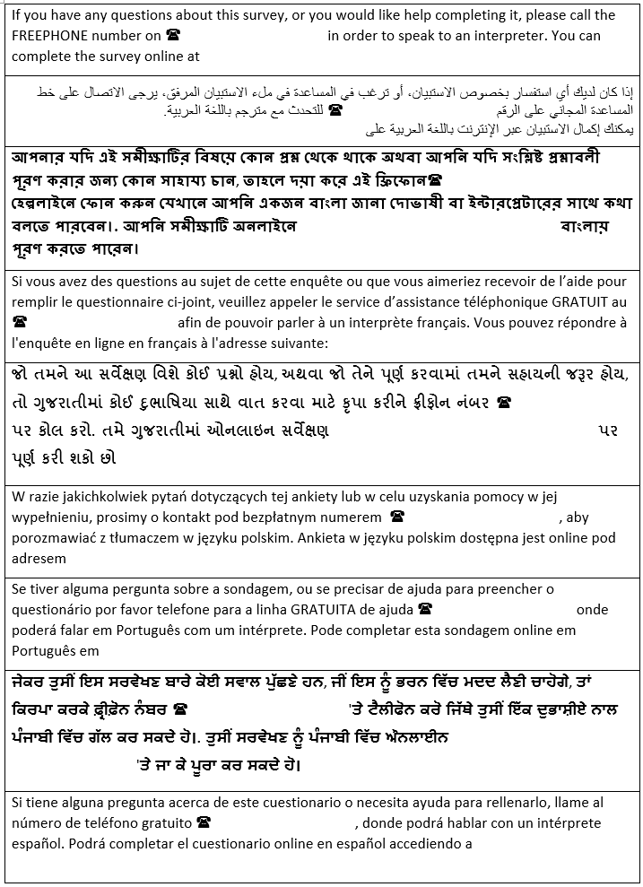
[INSERT HELPLINE]
[INSERT URL FOR ONLINE SURVEY]
[INSERT HELPLINE]
[INSERT HELPLINE]
[INSERT URL FOR ONLINE SURVEY]

[INSERT HELPLINE]
[INSERT URL FOR ONLINE SURVEY]
[INSERT URL FOR ONLINE SURVEY]
[INSERT URL FOR ONLINE SURVEY]
[INSERT URL FOR ONLINE SURVEY]

[INSERT HELPLINE]
[INSERT URL FOR ONLINE SURVEY]
[INSERT HELPLINE]
[INSERT URL FOR ONLINE SURVEY]

[INSERT URL FOR ONLINE

SURVEY]
[INSERT HELPLINE]
[INSERT HELPLINE]
[INSERT HELPLINE]
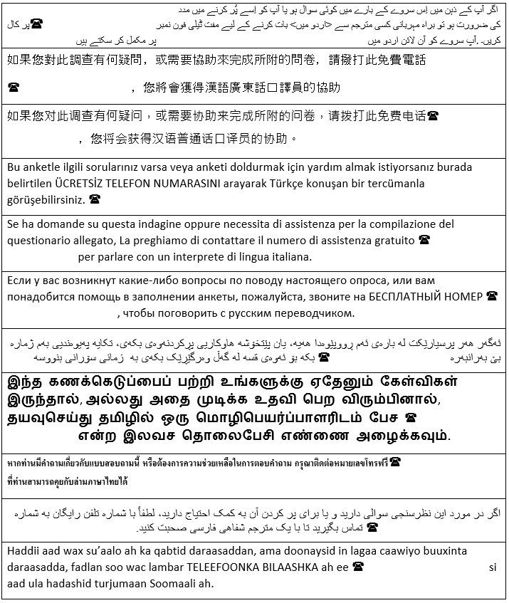
HELPLINE]
HELPLINE]
[INSERT HELPLINE]
HELPLINE]

[INSERT

[INSERT HELPLINE]

[INSERT HELPLINE]

[INSERT HELPLINE]

[INSERT HELPLINE]
[INSERT URL FOR ONLINE SURVEY]
[INSERT HELPLINE]
[INSERT
[INSERT

[INSERT HELPLINE]
[INSERT HELPLINE]

LEARNING DIFFICULTY OR ACCESSIBILITY NEEDS?

If you need some help to fill in this survey, or if you want a copy of the questionnaire in easy read, large print or Braille, please call us [for free] on [INSERT HELPLINE] or email [INSERT HELPLINE EMAIL].
[INSERT BSL LINK]

